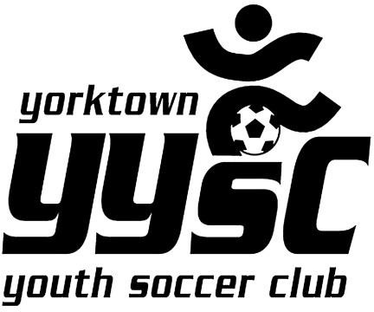
LABOR DAY TOURNAMENT 2023

Business Sponsor Advertisement

Team Name/Sold by: _
Advertiser’s Name: _ _
Advertiser’s Phone
Advertiser’s Email: _ _
Charitable Donation:
A gift made by an individual or an organization to a nonprofit organization,
charity or private foundation. Charitable donations are commonly in the form of cash, but can also take the form of real estate, motor vehicles, appreciated securities, clothing
and other assets or services.
Dear Sponsor:

The Yorktown Youth Soccer Club will be hosting our Annual 2022 Labor Day Soccer Tournament. We are asking you to support the YYSC Travel Teams by advertising with our club. Please choose one or more of the choices below:

This year we will be offering the following: Please Circle:

Choice 1 – Virtual Business Card Journal $150
Your business card in a “Virtual Directory” located on our website

Choice 2 - Field Sign $300
Your Business name and contact on a sign at the field
Choice 3-Email Blas
Sponsor information will be sent to all YYSC families for the amount of time purchased
Please circle one:

$300/3 months (3 blasts) $600/6 months (6 blasts $1200 / 1 year (12 blasts)

Choice 4- Uniform Advertising: Your Logo or company name will be placed on a club uniform- Due by 5/2023

1 Team $350
4 teams $1000

Choice 5- Banner Options-

4x8 Banner of fence at tournament (2 days) $500

Choice 6- Website advertising

Fixed logo on website

$300/6 months $600 / 1 year

Donation: (please circle one) $50 $75 $100 $250 $500
mail to:
YYSC
1928 Commerce Street Yorktown Heights, NY 10598
Phone (914) 214-8118 Email YYSC@VERIZON.NET

